 RYSTON PITCH AND PUTT CLUB
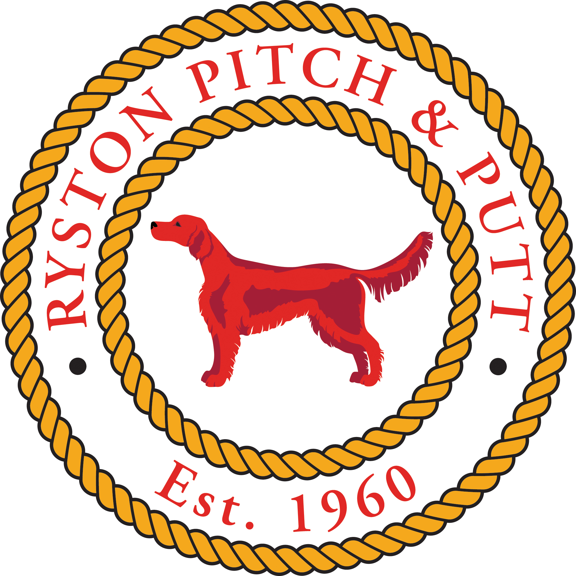
ub
Logo
Newbridge,
Co. Kildare
Adult Membership Form

Name: __________________________________ Male / Female: ______________
D.O.B.: _________________________________ PPI Reg No: ________________
Address: ___________________________________________________________________
___________________________________________________________________
Phone: ____________________ E-mail: __________________________________
Previous Club (if any): _____________________ Reg No.: ___________________
Previous Golf Club (if applicable) H/Cap
I hereby apply for membership of this club and for membership of Pitch and Putt Ireland (PPI).
I agree to comply with the rules of the club. I agree to be bound by the rules of Pitch and Putt Ireland. I understand that my membership may be reviewed at any time.
I understand that my personal information as pertained above will be used by the club to meet PPI registration requirements.
I understand that photographs may be taken during or at sport related events and may be used in the promotion of the sport.

Signed: _________________________________ Date: _____________________

Club Membership Rates
Adult: €120 OAP: €80 Student: €70
Juvenile: €70 Family membership: On Request Associate: €60

Optional Sections that require consent
If it is your club’s intention to gather information for any reasons other than maintaining a list of members, registering the members with the PPI or any club related activities you will then require permission from the person to use their information. Below are examples that can be copied and pasted into a club’s application form as required. The person has joined a Pitch and Putt Club, so club activities as described above are activities related to the sport of pitch and putt, anything outside of this would be outside the Legitimate Interest of the club and you would require a person’s consent to use the information for this purpose.

I have read the important Data Protection information on this form and have given my consent, by ticking the boxes and signing below, for my information to be used as follows: (Please tick as appropriate)
- To provide me with details of Club fundraising activities including Lotto, social occasions, ticket sales etc ☐
- To provide me with information related to third parties including club sponsors and marketing companies contracted by the club ☐
- To pass on to selected third parties for them to contact me in relation to promotional opportunities ☐
- I understand that I can withdraw my consent at any time by writing to the Club ☐

Social Club Application

Name: __________________________________ Male / Female: ______________
D.O.B.: _________________________________ PPI Reg No: ________________
Address: ___________________________________________________________________
___________________________________________________________________
Phone: ____________________ E-mail: __________________________________

