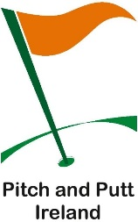 RYSTON PITCH AND PUTT CLUB
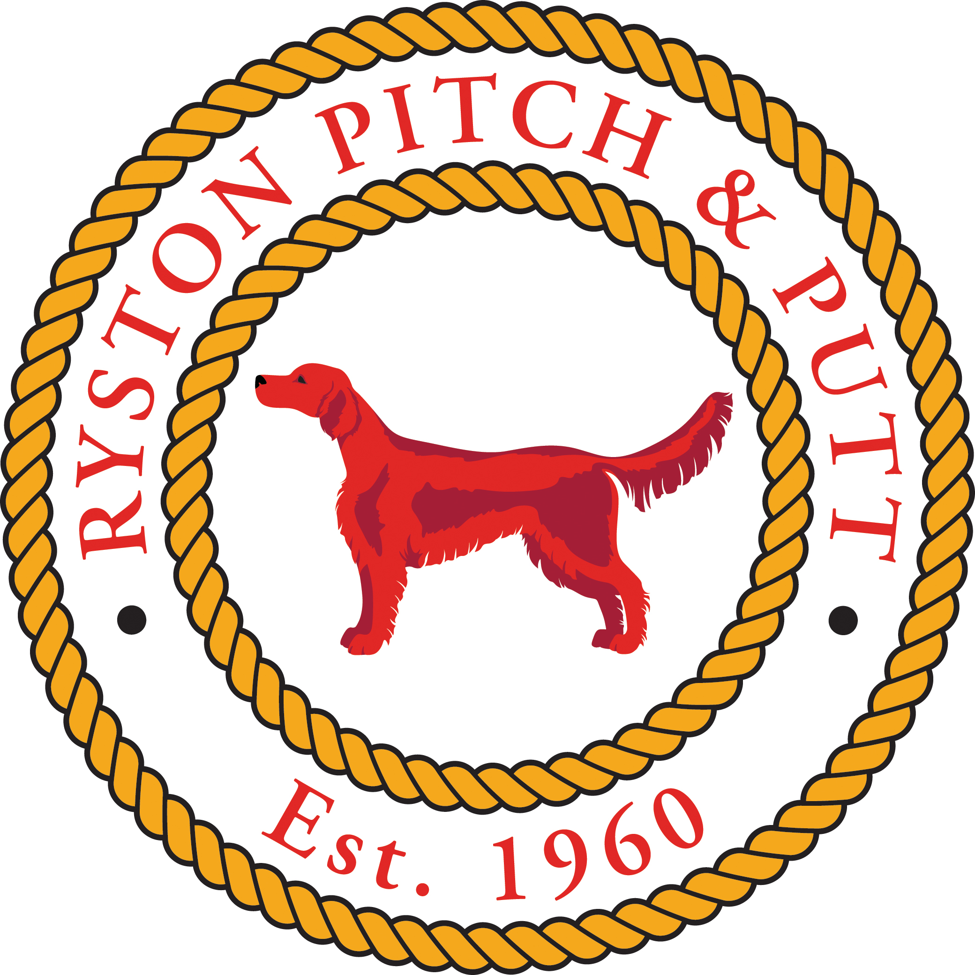
Newbridge,
Co. Kildare.

Membership 2026

Category | Fee
Adult | 120
OAP | 80
Associate | 60
Student | 70
Juvenile | 70
2 Juveniles (Siblings) | 130
3 Juveniles (Siblings) | 180
Family (1 Adult & 1 Juvenile) | 170
Family (1 Adult & 2 Juveniles) | 220
Family (2 Adults & 1 Juvenile) | 240
Family (2 Adults & 2 Juveniles) | 260
Other (On Request)

