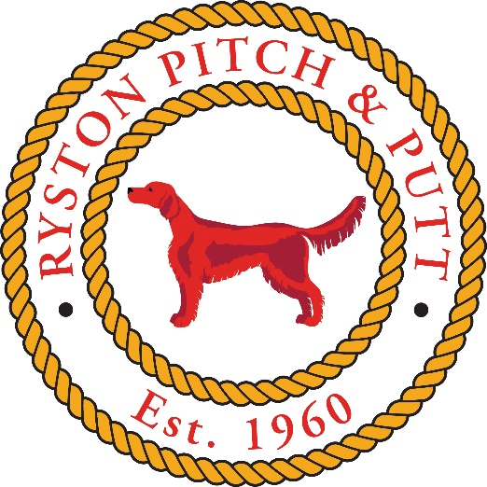

Green Fees : €5 per round

Green Fees to be paid before play

Tees must be used on the mats

If there is no-one around to take Green Fees – they can be revoluted to:

0868186778

