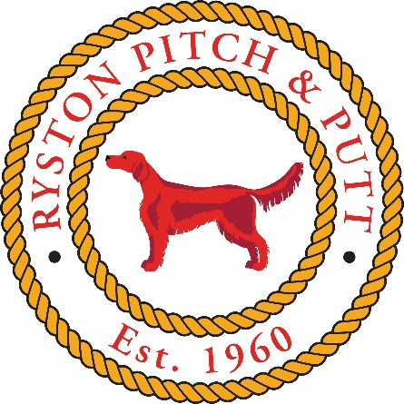

CODE OF CONDUCT

Misconduct Defined
Misconduct for the purposes of this document is improper interference, in the broadest sense, with the proper functioning or activities of Ryston Pitch and Putt Club, or those who work or play under its confines; or action which otherwise damages the anything under the Ryston Pitch and Putt Club control.
Subject to the general definition above, the following shall constitute misconduct:

Disruption of, or improper interference with the administrative, sporting, social or other activities of the Club, whether on club premises or elsewhere;
Obstruction of, or improper interference with the functions, duties or activities of any fellow member, member of staff or other volunteer of the Club or any authorised visitor.
Violent, indecent, disorderly, threatening or offensive behaviour or language whilst on any club premises while engaged in any Club activity;

Fraud, deceit, deception or dishonesty in relation to the Club or its staff or in connection with holding any office in the Club or in relation to being a member of the Club;
Behaviour likely to cause injury or impair safety on Club premises;
Sexual, racial or any other form of personal harassment of any fellow member, member of staff or other member of the Club or any authorised visitor;
The use of any unfair means in competition;
Damage to, or defacement of, club property or the property of other members, caused intentionally or recklessly, or misappropriation of such property.
Conduct which constitutes a criminal offence where that conduct:
takes place on Club premises, or
affects or concerns other members of the Club or members of the public, or
itself constitutes misconduct within the terms of these Regulations, or
is an offence of dishonesty, where the member holds an office of responsibility in the Club;
Conduct which brings or is likely to bring the Club into disrepute
Conduct which contravenes a previously-imposed penalty, requirement or undertaking under these Regulations;
This code applies to all members of the Club.
All members, including new members are subject to this code.

Appropriate behaviour and etiquette for members of the Club
Subject to the broad examples of misconduct, this code of conduct specifically states that the following are examples of appropriate etiquette

All the rules of the PPI (Pitch & Putt Ireland) apply, without exception. It is the duty of every member to become familiar with all such rules.
All local rules, as displayed in a clubhouse or on a score card must be adhered to. It is the duty of every member to become familiar with all local rules and to all changes to the local rules.
Before commencement of play in any competition the member must pay the entry fee.
Competitors must adhere to the Dress Code at all times – failure to do so will lead to withdrawal from competition.
Players must be punctual, turn up on time and register before their allotted time in order to be eligible to compete in any Club event.
While playing on the course:
Show respect to fellow players and Club Officials.
Avoid slow play at all times.
Repair plug marks on the greens.
No player shall play until the group in front have reached the next tee box.
If a match fails to keep its place and loses in distance more than two clear holes on those in front it may be passed on request being made.
Players searching for a ball should signal oncoming players to pass them.
Always repair divots and any plug marks you see on the green, whether left by you or others. Bunkers must be carefully raked after your stroke. Leave the rake inside the bunker afterwards.

While playing in competition:
The number of shots must be recorded by the marker of the scorecard.
Competitors should return all cards in competitions.
Scorecards must be signed and have correct handicap.
Local rules posted in the clubhouse or on entry to the course must be observed without exception.
Note: The above is not meant to be an exclusive list of rules or etiquette. Any of the above may be amended by the Ryston Pitch and Putt Club at a properly convened meeting or at an AGM or EGM of members.

Sanctions
Any one or more of the following penalties may be imposed for a breach of the code of conduct:

a reprimand;
a written warning;
suspension from club competition;
Proposing to the PPUI the suspension of the member’s handicap;
with the consent of the member, a requirement that the member gives an undertaking as to future conduct in such terms and containing such conditions as the Committee may prescribe, breach of the undertaking to constitute misconduct;
Note: In the case of charges pertaining to cheating (where it has been proved and accepted) that the member be disqualified and any prize pertaining be withdrawn/returned;
exclusion for a stated period or permanently from any part of the course or from the participation in competitions run by the Club;
suspension for a stated period from membership of the Club;
expulsion from membership of the Club.
Any member subject to the sanctions above will be notified in writing by the Club and be given the opportunity to defend themselves prior the sanction being enforced.
Within all of the above, any sanctioned player will have right of appeal to their Club, County Board and PPI through the normal procedures as set out by the PPI.

Note: The above is not meant to be an exclusive list of sanctions. Any of the above may be amended by the Ryston Pitch and Putt Club at a properly convened meeting or at an AGM or EGM of members.

